Module 3 : Assignment 1

Created two separate branches from master

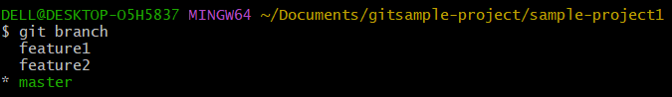

Make changes in the same function of the source code in both the branches to the file index.html

Merge feature1 & feature2 branches into the master

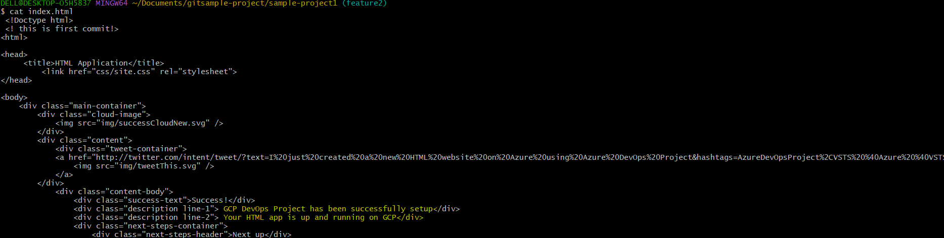



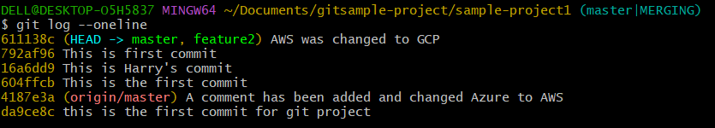

After second commit on feature1 tried to merge into master, conflict arises

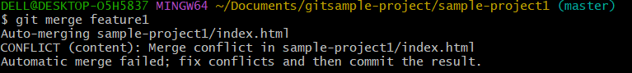

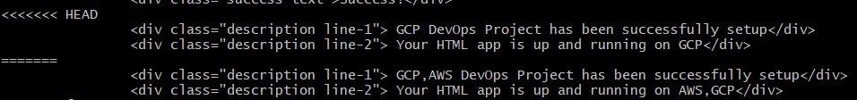

Installed a merge tool vimdiff2 and resolved the issue



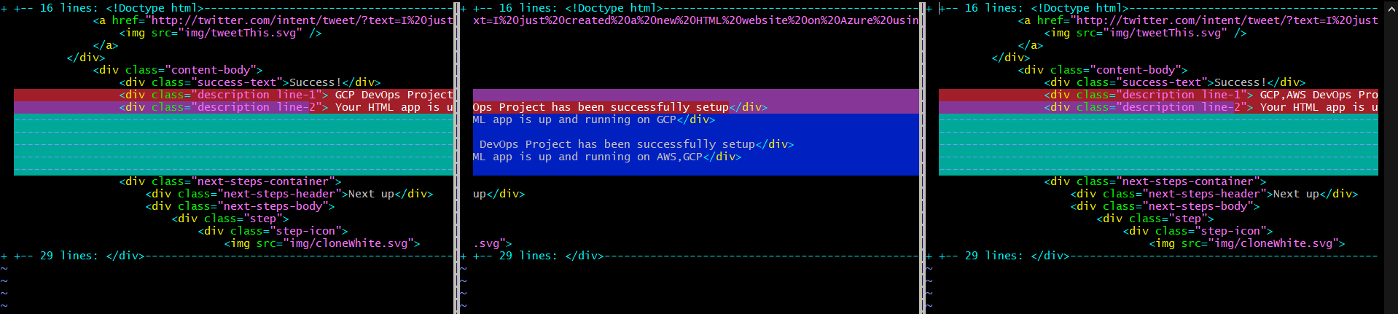

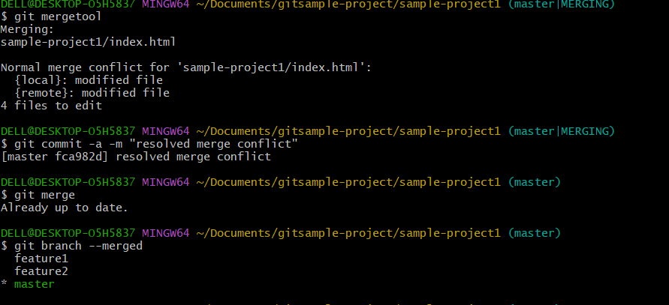

**Steps to remove directory from a repository in github –**

git rm -r --cached FolderName

git commit -m "Removed folder from repository"

git push origin master